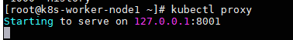
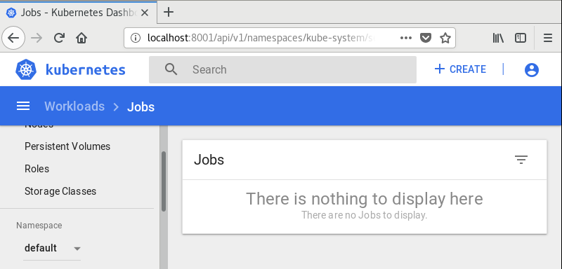
Deploying the Dashboard UI of Kubernetes

Dashboard is a web-based Kubernetes user interface. You can use Dashboard to deploy containerized applications to a Kubernetes cluster, troubleshoot your containerized application, and manage the cluster resources. Deploying process are below;
Step-1: The Dashboard UI is not deployed by default. To deploy it, run the following command:
kubectl apply -f https://raw.githubusercontent.com/kubernetes/dashboard/v2.0.0-beta4/aio/deploy/recommended.yaml
or
kubectl apply -f https://raw.githubusercontent.com/coreos/flannel/v0.9.1/Documentation/kube-flannel.yml
After successful installation of dashboard use the below command to see that kubernetes Dashboard service is running or not.
# kubectl get pods –all-namespaces

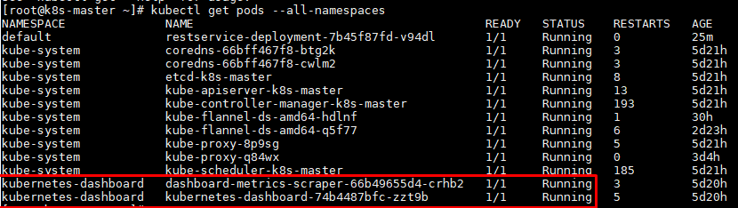
To get all namespace use below commands and you will get kubernetes-dashboard namespace is active.
# kubectl get ns
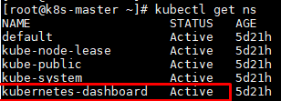
For viewing the details of kubernetes-dashborad namespace use the below command.
# kubectl -n kubernetes-dashboard get all
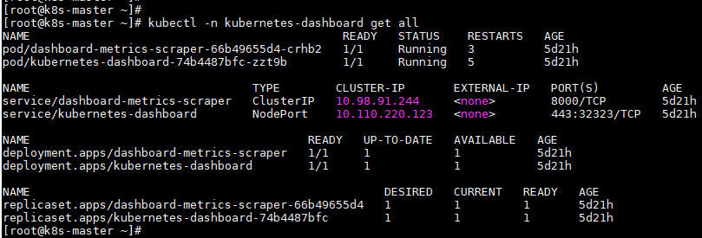
Step-2: Command line proxy
You can access Dashboard using the kubectl command-line tool by running the following command:
kubectl proxy
Step-3: Kubectl will make Dashboard available at
http://localhost:8001/api/v1/namespaces/kubernetes-dashboard/services/https:kubernetes-dashboard:/proxy/

NOTE: Dashboard should not be exposed publicly using kubectl proxy command as it only allows HTTP connection. For domains other than localhost and 127.0.0.1 it will not be possible to sign in. Nothing will happen after clicking Sign in button on login page.
You can change and publish the service kubernetes-dashboard as NodePort type, then access the dashboard with the specified NodePort.
So now we will edit the kubernetes dashboard service.
# kubectl -n kubernetes-dashboard edit svc kubernetes-dashboard
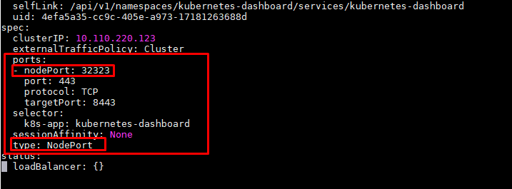
Here we are changing the type :NodePort and specifying the nodeport to 32323 and Save this.
Now get the kuberntes dashboard service using below command
# kubectl -n kubernetes-dashboard get svc
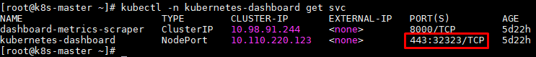
Here we can see that kubernetes-dashborad service now running as NodePort type and nodeport is 32323.
So now we should be able to open the dashboard externally using https://serverip:32323

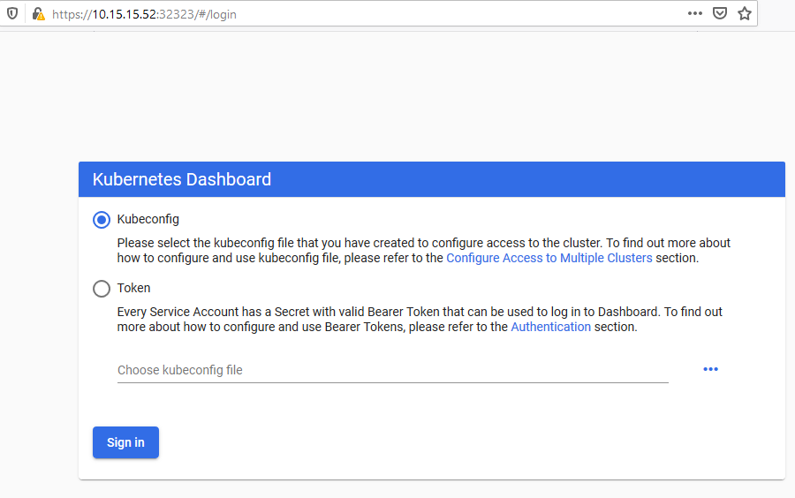
Accessing the dashboard using token
Now describe the kubernetes-dashboard service to grap what token it's using .
# kubectl -n kubernetes-dashboard describe sa kubernetes-dashboard
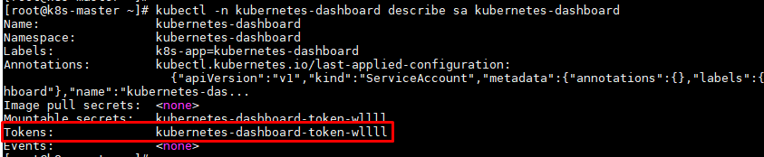
Now describe the tokens to grab the secrects
# kubectl -n kubernetes-dashboard describe secret kubernetes-dashboard-token-wllll
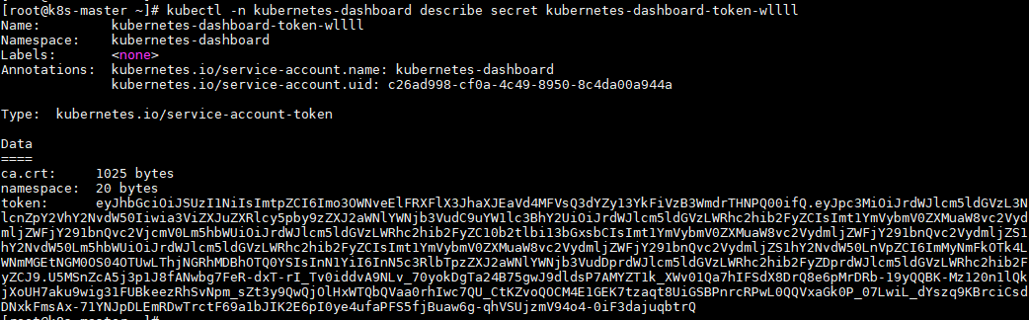
Now copy the secrtes and paste it by selecting Token on web UI. You should be able to access the dashboard.
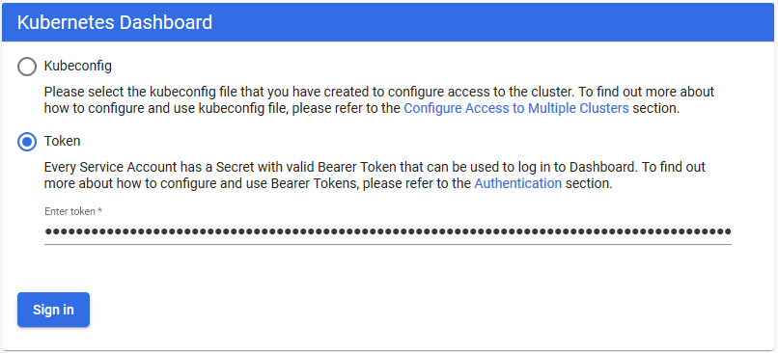
But this accound does have admin privileges to see the cluster. So now we have to create a new service account which have ClusterRole.
So for that create a .yaml file and write the below description and save it.
# vi dashboard-admin.yaml
apiVersion: v1
kind: ServiceAccount
metadata:
name: dashboard-admin
namespace: kube-system
---
apiVersion: rbac.authorization.k8s.io/v1beta1
kind: ClusterRoleBinding
metadata:
name: cluster-admin-rolebinding
roleRef:
apiGroup: rbac.authorization.k8s.io
kind: ClusterRole
name: cluster-admin
subjects:
- kind: ServiceAccount
name: dashboard-admin
namespace: kube-system

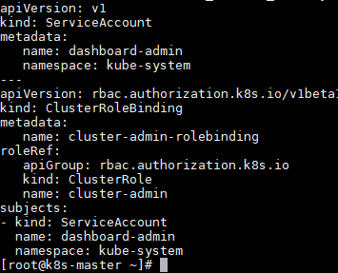
Now run the yaml file using command # kubectl create -f dashboard-admin.yaml
A service account named dashboard-admin will be created.
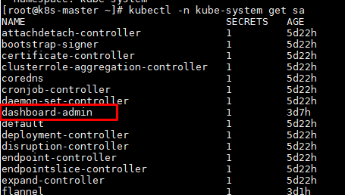
Now describe the service account dashboard-admin
# kubectl -n kube-system describe sa dashboard-admin
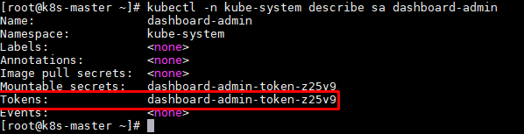
Now copy the token and you should be able to access the dashboard and you will have admin privileges.
